F-16 Capstone

Sensor Noise Analysis

4/25/2021

Table of Contents

1. IMU in PX4 4

1.1 Velocity (PX4) 4

a. Time Domain Plot 4

b. Mean Value and Standard Deviation 5

c. Power Spectral Density Plot 6

d. Distribution Histogram 6

1.2 Acceleration (PX4) 7

a. Time Domain Plot 7

b. Mean Value and Standard Deviation 8

c. Power Spectral Density Plot 8

d. Distribution Histogram 9

1.3 Angular Velocity (PX4) 10

a. Time Domain Plot 10

b. Mean Value and Standard Deviation 11

c. Power Spectral Density Plot 11

d. Distribution Histogram 11

2. IMU Sensor 13

2.1 Acceleration (Sensor) 13

a. Time Domain Plot 13

b. Mean Value and Standard Deviation 14

c. Power Spectral Density Plot 15

d. Distribution Histogram 15

2.2 Angular Velocity (Sensor) 16

a. Time Domain Plot 16

b. Mean Value and Standard Deviation 17

c. Power Spectral Density Plot 18

d. Distribution Histogram 18

3. Airspeed 19

a. Time Domain Plot 19

b. Mean Value and Standard Deviation 20

c. Power Spectral Density Plot 20

d. Distribution Histogram 21

1. IMU in PX4
   1. Velocity (PX4)

**Sample frequency: 10 Hz**

a. Time Domain Plot

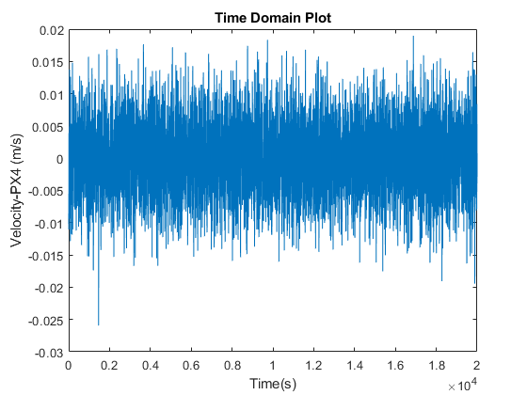

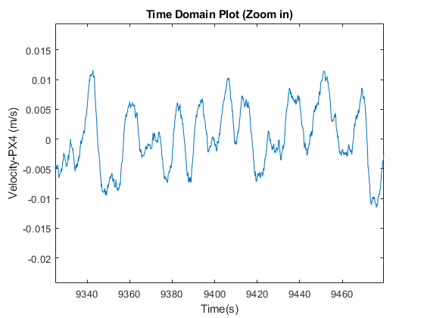

b. Mean Value and Standard Deviation

|  |  |
| --- | --- |
|  | Value |
| Mean Value | -1.87*10-4 m/s |
| Standard Deviation | 0.0054 m/s |

c. Power Spectral Density Plot

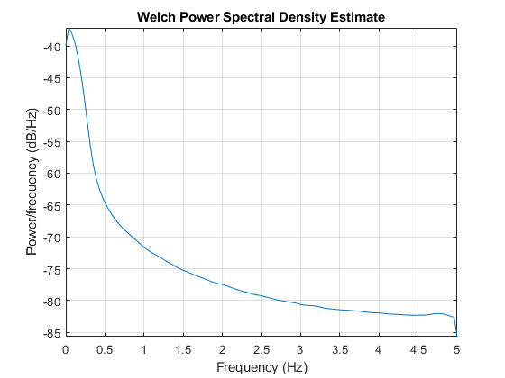

d. Distribution Histogram

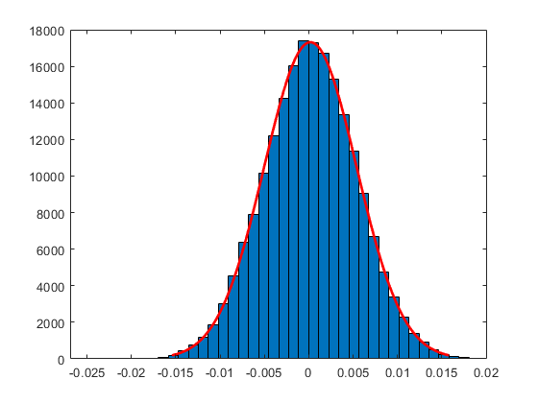

* 1. Acceleration (PX4)

**Sample frequency: 10 Hz**

a. Time Domain Plot

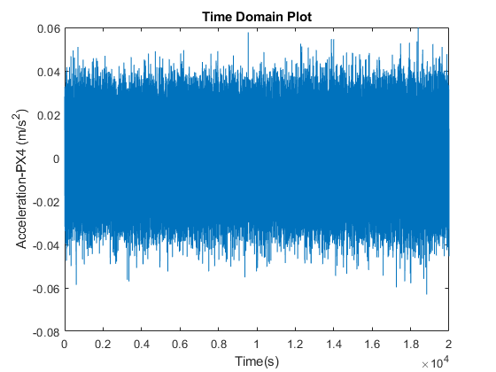

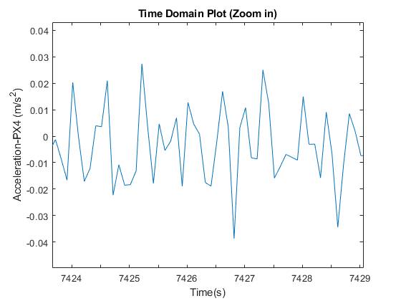

b. Mean Value and Standard Deviation

|  |  |
| --- | --- |
|  | Value |
| Mean Value | -1.20*10-6 m/s2 |
| Standard Deviation | 0.0133 m/s2 |

c. Power Spectral Density Plot

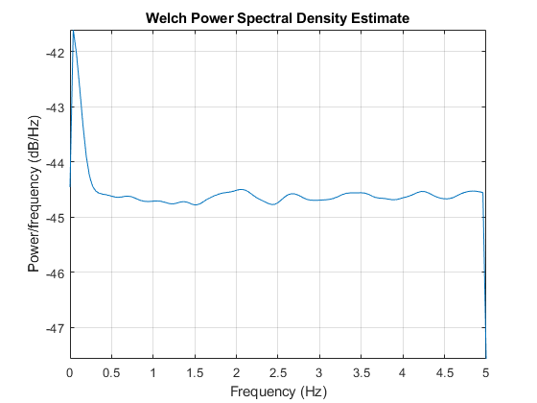

d. Distribution Histogram

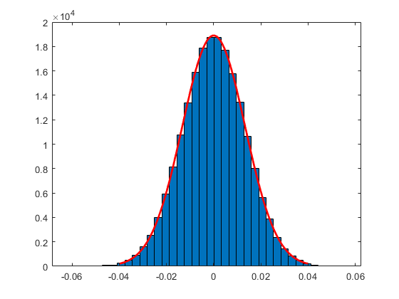

* 1. Angular Velocity (PX4)

**Sample frequency: 50 Hz**

a. Time Domain Plot

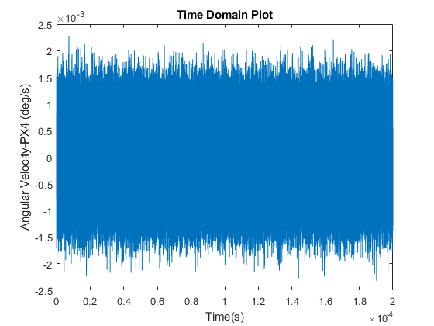

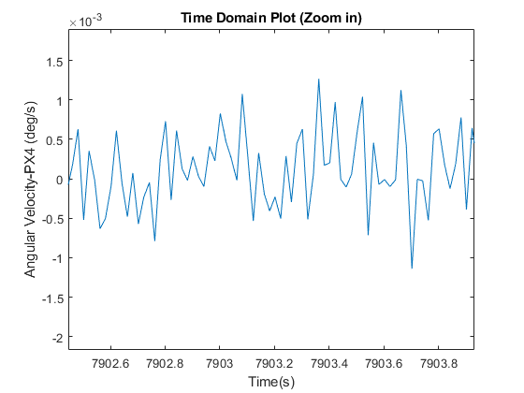

b. Mean Value and Standard Deviation

|  |  |
| --- | --- |
|  | Value |
| Mean Value | -1.74*10-6 deg/s |
| Standard Deviation | 4.99*10-4 deg/s |

c. Power Spectral Density Plot

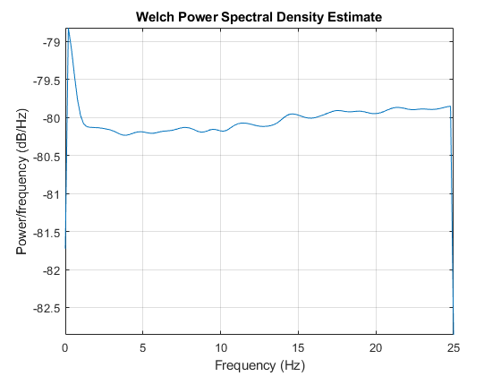

d. Distribution Histogram

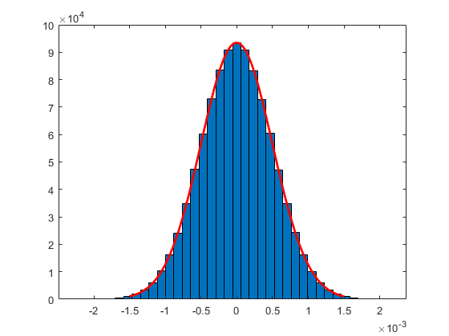

1. IMU Sensor
   1. Acceleration (Sensor)

Sample frequency: 1 Hz

a. Time Domain Plot

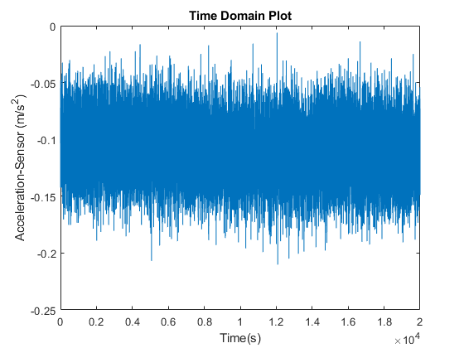

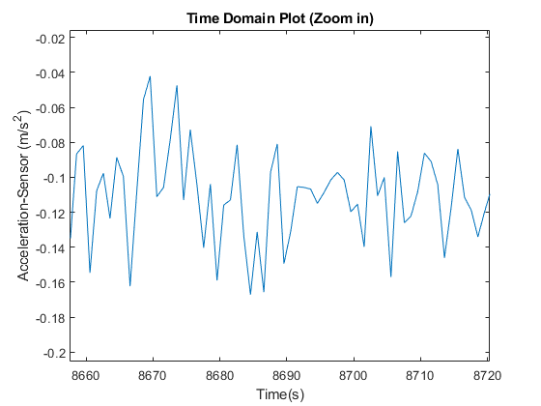

b. Mean Value and Standard Deviation

|  |  |
| --- | --- |
|  | Value |
| Mean Value | -0.109 m/s2 |
| Standard Deviation | 0.0266 m/s2 |

c. Power Spectral Density Plot

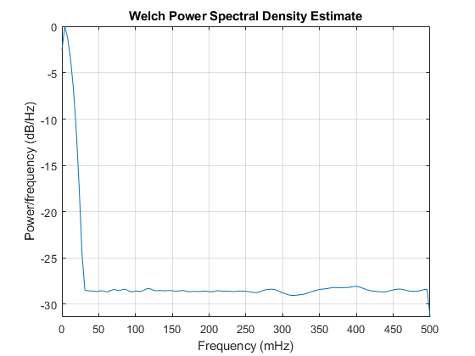

d. Distribution Histogram

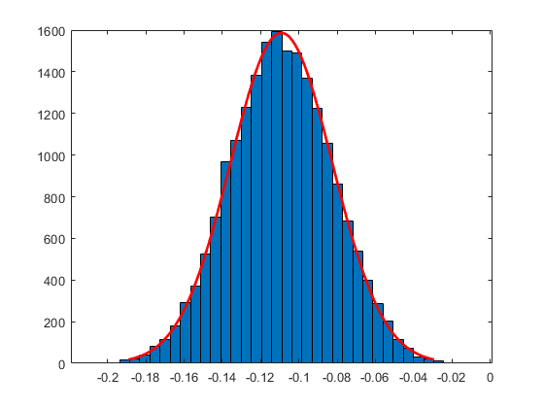

* 1. Angular Velocity (Sensor)

Sample frequency: 1 Hz

a. Time Domain Plot

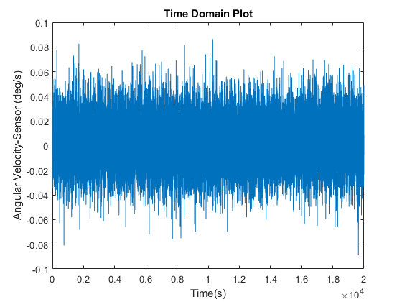

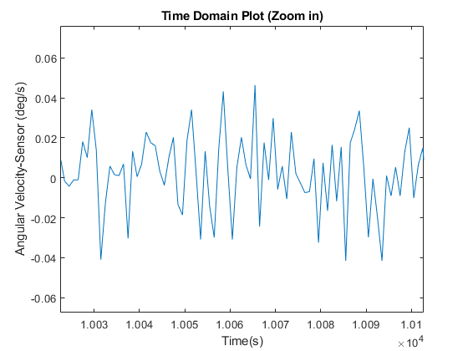

b. Mean Value and Standard Deviation

|  |  |
| --- | --- |
|  | Value |
| Mean Value | 0.0028 deg/s |
| Standard Deviation | 0.0202 deg/s |

c. Power Spectral Density Plot

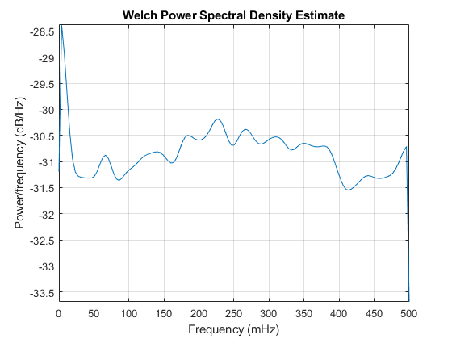

d. Distribution Histogram

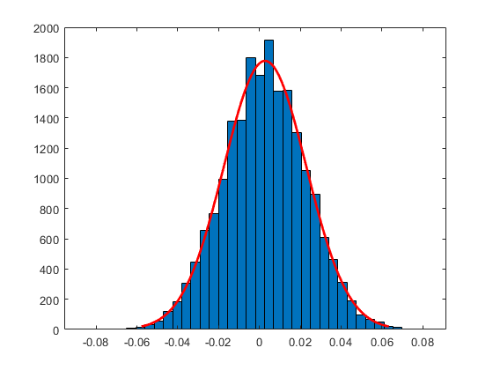

1. Airspeed

Sample frequency: 1 Hz

a. Time Domain Plot

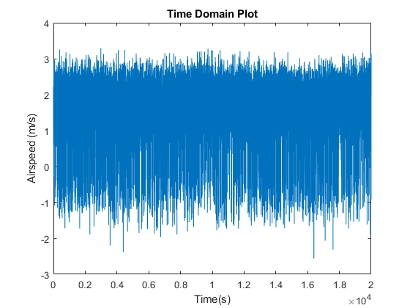

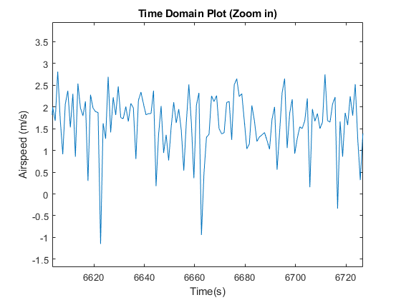

b. Mean Value and Standard Deviation

|  |  |
| --- | --- |
|  | Value |
| Mean Value | 1.657 m/s |
| Standard Deviation | 0.811 m/s |

c. Power Spectral Density Plot

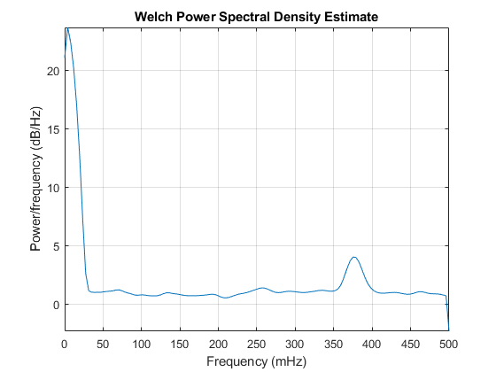

d. Distribution Histogram

